**Gujarat Technological University** 

**Chandkheda, Ahmedabad**

**Affiliated**

**Vishwakarma Government Engineering College**

A

Project Report

On

**Automation using GSM Module**

Under Subject of

**Design Engineering-IA**

B.E. II, Semester III

EC Branch

Submitted by:

Sr. No. Name Enrollment No.

1 Kunal Ramchandani 180170111091

2 Divyanshu Soni 180170111108

3 Romit Srivastav 180170111110

4 Ronak Tandon 180170111113

5 Dhruv Vats 180170111121

Prof Dhara Sangani Prof M.S Shah

**Faculty Guide Head of the Department**

Academic year

2019-2020

**CANDIDATE’S DECLARATION**

We have finished our project report entitled”​**Automation using GSM Module**” and submitted to our respective guide. We are in 3​rd semester and we have tried to give our best. We have done our work honestly and in a good way.

|  |  |  |
| --- | --- | --- |
|  | : **​Kunal Ramchandani** |  |
| First Candidate’s Name |  |
| Branch | : ​**ECE** |  |
| Enrollment No. | : ​​**180170111091** |  |
|  |  |  |
| Second Candidate’s Name :​ **Divyanshu Soni** | |  |
| Branch | : ​**ECE** |  |
| Enrollment No. | : ​​​**180170111108** |  |
|  |  |  |
| Third Candidate’s Name | **: Romit Srivastav** |  |
| Branch | **:ECE** |  |
| Enrollment No. | **:180170111110** |  |
|  |  |  |
| Fourth Candidate’s Name | **: Ronak Tandon** |  |
| Branch | : **ECE** |  |
| Enrollment No. | : **180170111113** |  |

Fifth Candidate’s Name :  **Dhruv Vats**

Branch : E**CE**

Enrollment No. : **180170111121**

Submitted to: Vishwakarma Government Engineering College, Ahmedabad.

Affiliated to:Gujarat technological university.



Plagiarism Checker X Originality Report

**Similarity Found: 22%**

Date: Monday, October 14, 2019

Statistics: 1158 words Plagiarized / 5268 Total words

Remarks: Medium Plagiarism Detected - Your Document needs Selective Improvement.

-------------------------------------------------------------------------------------------

/Gujarat Technological University / Chandkheda, Ahmedabad Affiliated Vishwakarma Government Engineering College A Project Report On **Automation using GSM** Under Subject of Design Engineering-IA B.E. II, Semester III EC Branch Submitted by: Sr. No. Name Enrollment No. 1Kunal Ramchandani (180170111091) 2 Divyanshu Soni (180170111108) 3 Romit Srivastav (180170111110) 4 Ronak Tandon (180170111113) 5 Dhruv Vats (180170111121)

INTERNET SOURCES:

-------------------------------------------------------------------------------------------

5% - https://conspiracyofarsonists.com/gujarat-technological-university/

6% - https://www.slideshare.net/milinpatel954/gearless-transmission-76405859

**ACKNOWLEDGEMENT**

We would like to extend our heartily thanks with a deep sense of gratitude and respect to all those who has provided us immense help and guidance during our project.

We would like to express our sincere thanks to our internal guide **(Prof. Dhara Sangani**) for providing a vision about the system and for giving us an opportunity to undertake such a great challenging and innovative work. We are grateful for the guidance, encouragement, understanding and insightful support given in the development process.

We would like to extend my gratitude to Head of Electronics and Communication Engineering Department, Vishwakarma Government college of Engineering and Technology, Ahmedabad, for his continuous encouragement and motivation.

Last but not the least we would like to mention here that we are greatly indebted to each and everybody who has been associated with our project at any stage but whose name does not find a place in this acknowledgement.

Yours Sincerely,

​​

1 Kunal Ramchandani 180170111091

2 Divyanshu Soni 180170111108

3 Romit Srivastav 180170111110

4 Ronak Tandon 180170111113

5 Dhruv Vats 180170111121

**Table of contents**

Sr. No. Title Page No.

1. Title page 01

2. Table of contents 04

3. Abstract 05

4. Introduction of Project 06

5. **Canvas:**

1. Empathy Canvas 07
2. A.E.I.O.U Canvas 09
3. Mind map Canvas 10
4. Ideation canvas 11
5. Product development Canvas 13
6. Conclusion 14

**Abstract**

Mobile phone is a revolutionary invention of the century. It was primarily designed for making and receiving calls & text messages, but it has become the whole world after the Smart phone comes into the picture. In this project we are building a home automation system, where one can control the home appliances, using the simple GSM based phone, just by sending SMS through his phone. In this project, no Smart phone is needed, just the old GSM phone will work to switch ON and OFF any home electronic appliances, from anywhere.

1. **INTRODUCTION**

The circuit consists of a **GSM Module** and a **Controller circut**. The components used in the experiment are as follows.

* Controller
* GSM Module
* Relay 5 volt
* Connecting wires
* Bread board
* 16x2 LCD
* Power supply
* Cell phone
* PDBs
* Sheilds
* Switches and Connectors
* Voltage Regulators

**2. Specifications**

* Power Supply: Requires a Minimum voltage of 5V and can withstand up to 18V
* Input Impedance: About 2 mega ohms
* Output impedance: About 75 ohms
* Maximum Output Current: 20mA
* Recommended Output Load: Greater than 2 kilo ohms
* Input Offset: Ranges between 2mV and 6mV
* Slew Rate: 0.5V/microsecond (It is the rate at which an Op-Amp can detect voltage changes)
* The high input impedance and very small output impedance makes IC 741 a near ideal voltage amplifier.

**3. Circuit Description**

* Connections of this GSM based home automation circuit are quite simple, here a liquid crystal display is used for displaying status of home appliances which is directly connected to arduino in 4-bit mode.
* Data pins of LCD namely RS, EN, D4, D5, D6, D7 are connected to arduino digital pin number 6, 7, 8, 9, 10, 11. And Rx and Tx pin of GSM module is directly connected at Tx and Rx pin of Arduino respectively. And GSM module is powered by using a 12 volt adaptor. 5 volt SPDT 3 relays are used for controlling LIGHT, FAN and TV.
* And relays are connected to arduino pin number 3, 4 and 5 through relay driver ULN2003 for controlling LIGHT, FAN and TV respectively.

4. **APPLICATIONS**

* Adds Safety Through Appliance and Lighting Control
* Saves Money and Increases Convenience
* Another home automation advantage is added safety for both your family and home. You have the ability to control the small appliances and lighting, again with the simple tap of your finger on your favorite technological device.
* Allows You Control When Out of Town
* Can be easily implemented at our homes.
* Can be used by anyone with just the knowledge of how to use application.
* Completely user contolrolled device.

5. **LIMITATIONS**

* The system is totally **Network Dependent**. Hence, Network Congestion can reduce the reliability of the system
* Must be kept away from children , as one single wrong touch in the application can send a wrong message to the Controller Circuit and this may results to a dangerous situation.

6. **FUTURE SCOPES**

* This project "**HOME AUTOMATION USING GSM**" is intended to automate certain functions of appliances. With the further advancement of technologies and communication sector new development can be done in this project.
* This will make possible for wireless technologies to soon be accessed at low cost and economically affordable prices.
* The device is very useful in controlling electronic appliances using **IOT** and reduce the wastwge of energy and time.

**Empathy canvas**

To define any user’s centric problem we need to know the user properly. That was what this canvas was all about.

We thought about so many people but wanted to go for some people that mostly remain untouched by technology but are larger in number.

They cover a large mass but are least touched with technology.

**Story boarding**

Most interesting part was the ‘Story Boards’ which can be called the board of emotion understanding the problem of society is one of the biggest challenges for engineering student as till now they were making projects on imaginary ideas.

It helped us understanding that when we build anything for anyone, the purpose and emotion behind that are equally important.

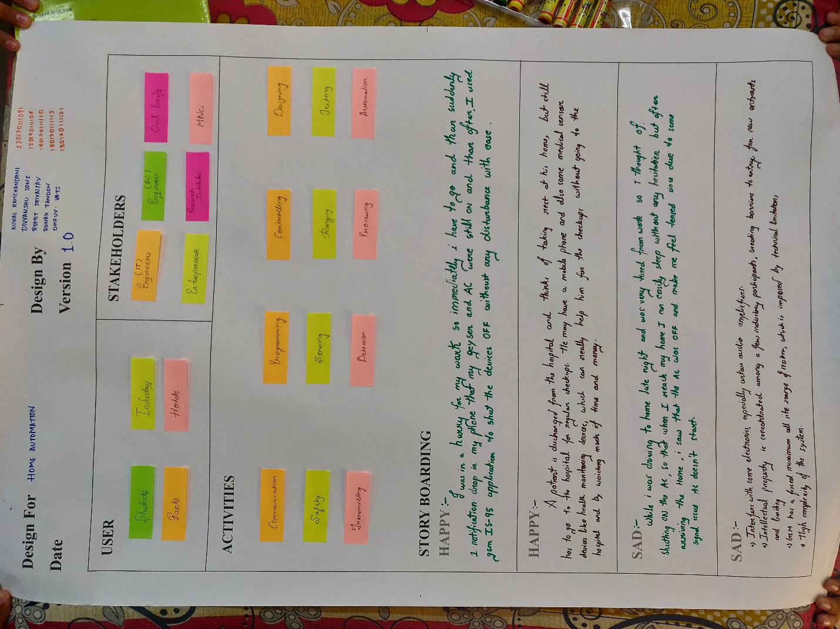

**AEIOU Canvas**

Activity Canvas was the portion, in which we had to include the activities that people carry out in their life. We tried to note down all the security and safety activities that goes on in the background.

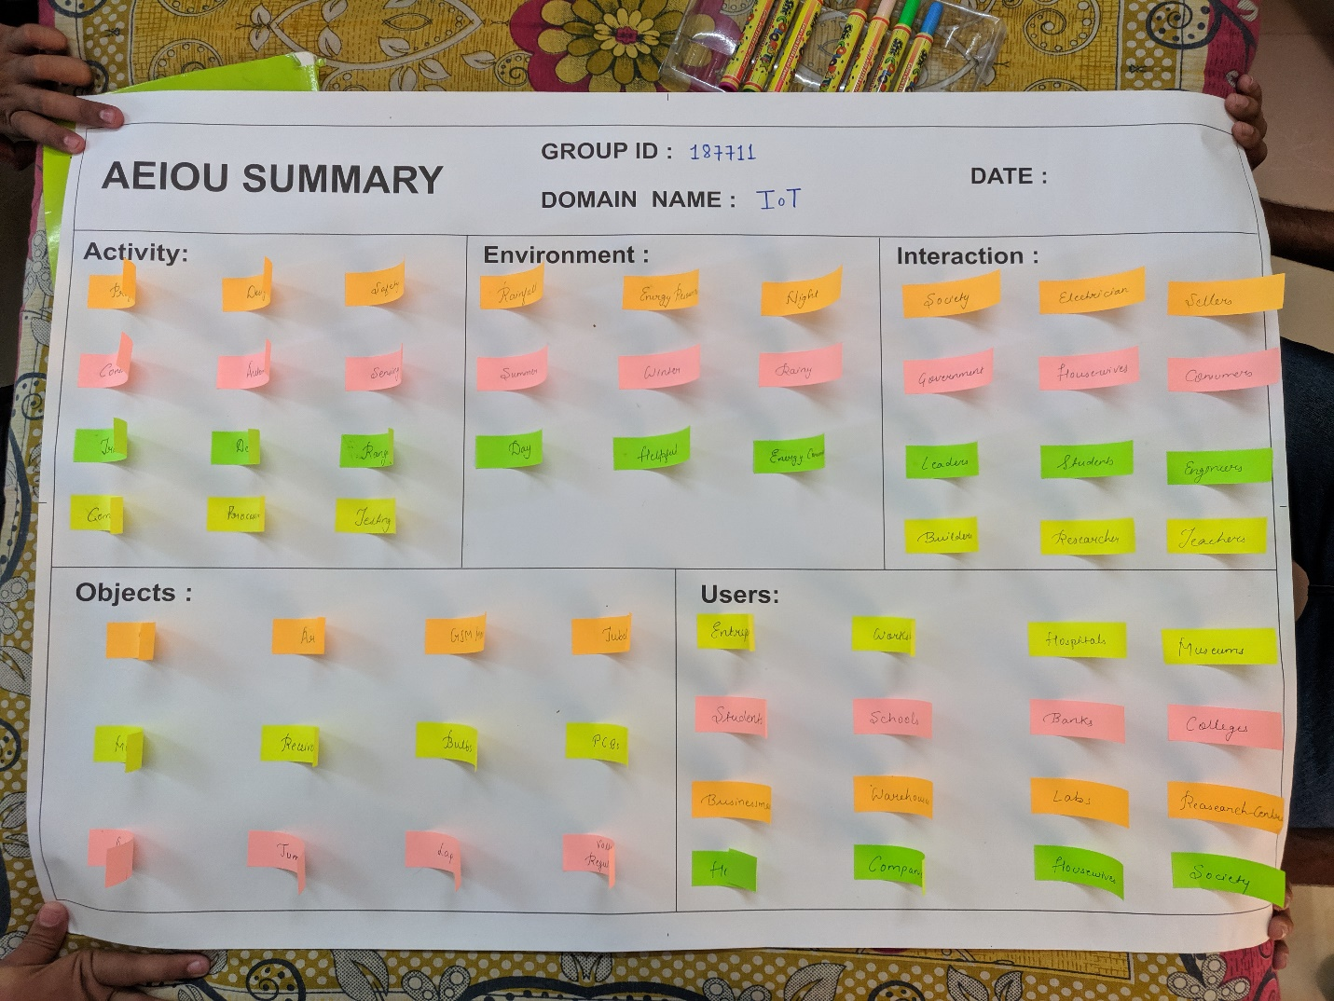

**Mind map**

This canvas is summarization canvas for all the other canvases we used during the designing process. We included users in our canvas users are the persons who use this application or who are connected with this sector. Also we include problems and solutions in this canvas. This canvas is very useful to develop application.

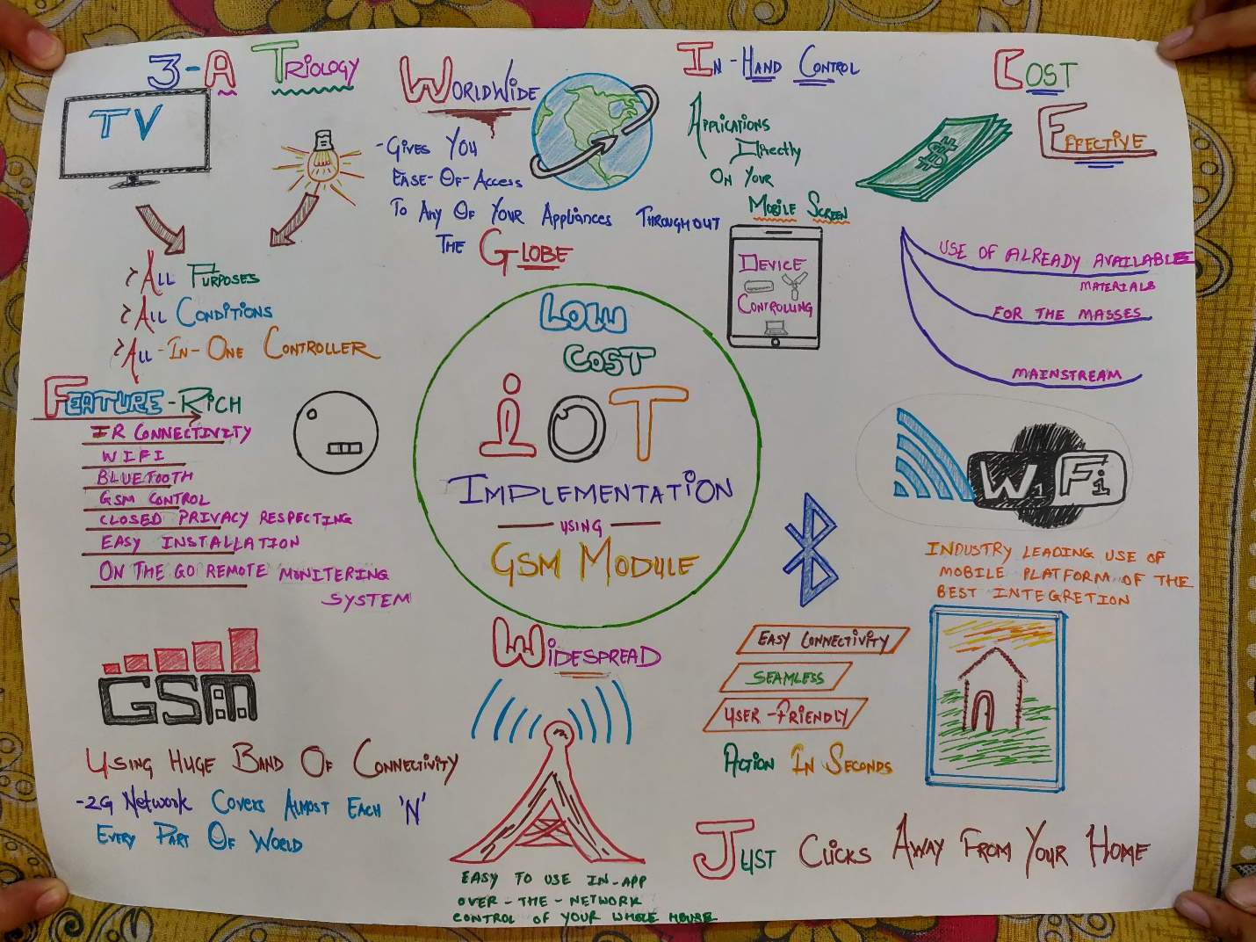

**Ideation Canvas**

In ideation canvas we started with people. people includes that who can be connected with our project. There are various people who are connected with our project like people with hand disability,Medical sector,Automation systems Then we listed out that what activity every segment of people does. Then we thought about situation/context/location and finally for possible solutions.

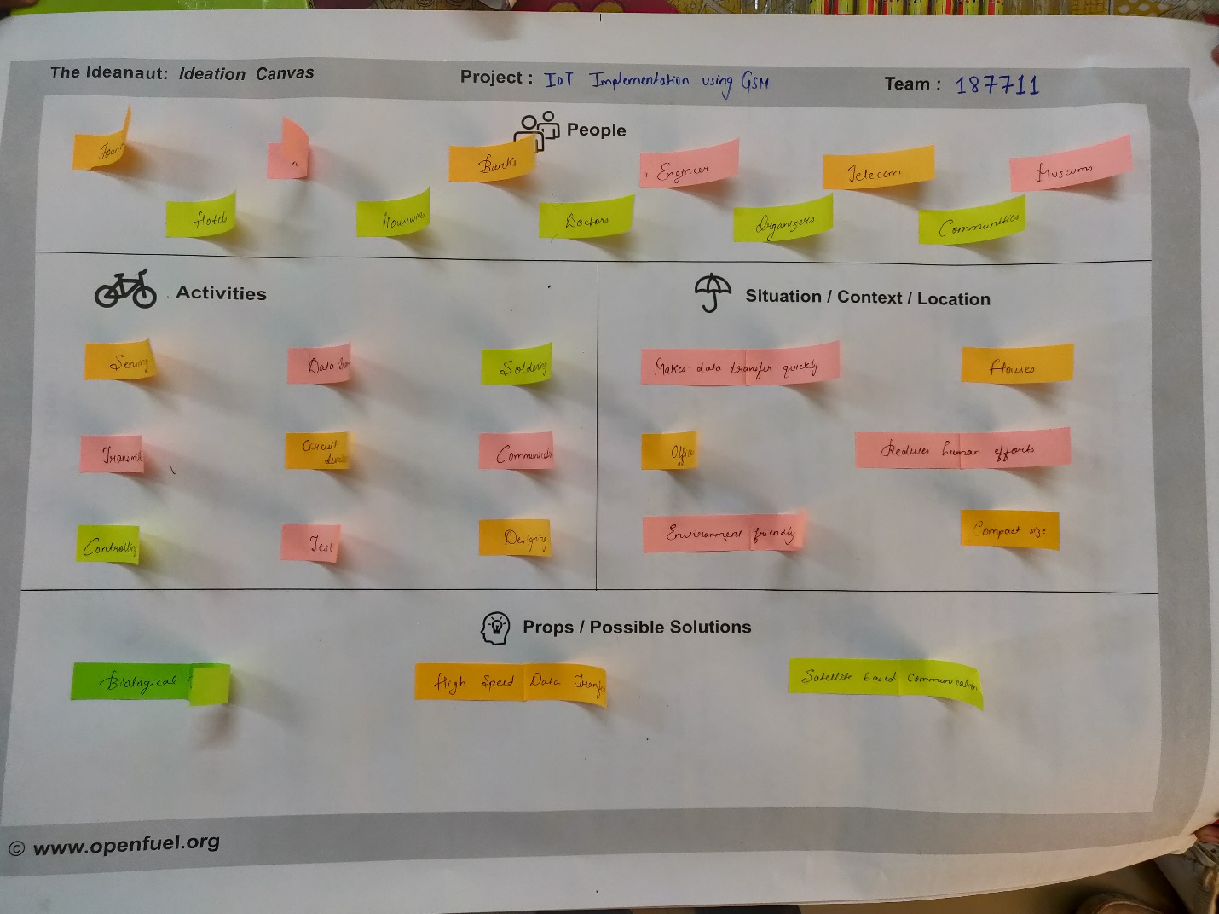

**Product Development Canvas**

In this canvas we mentioned purpose of our product, functions, features and products experience.

For this purpose, we defined some functions that our product must do. These included, for each of the function that our product fulfills, also there is some features of our product.

The components which are required for our product is also mentioned.

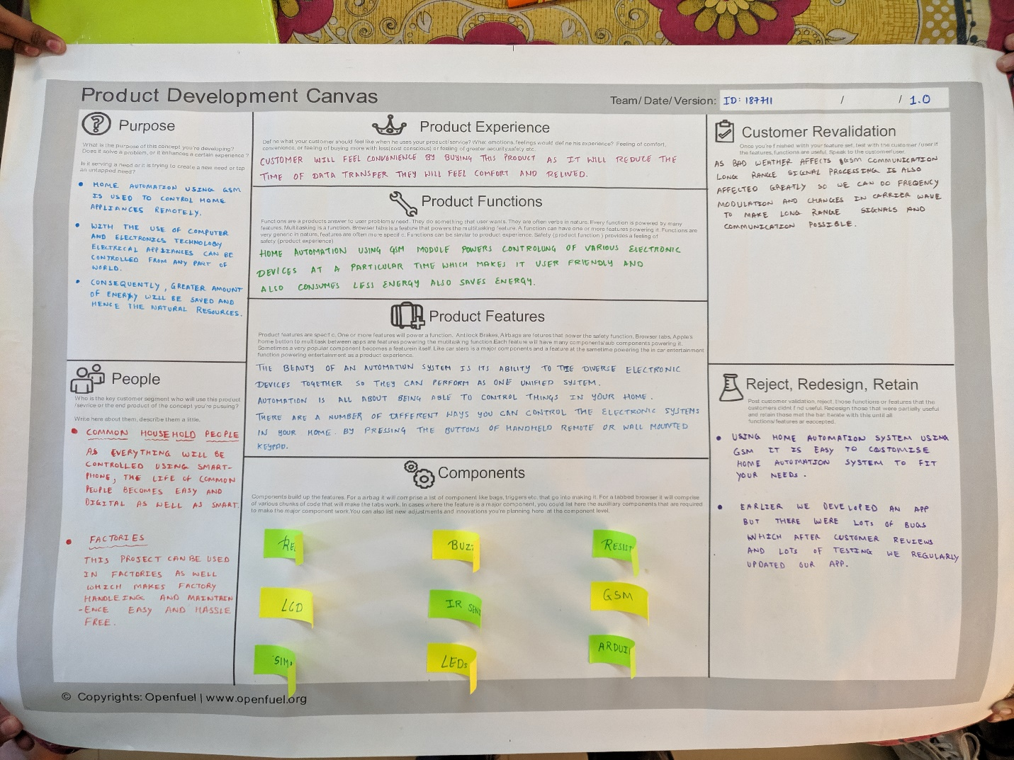

**Conclusion**

The main purpose of the project is to provide a smart and efficient way to control the electronic devices with the help of modern communication technologies. With the use of Controllers and Modules this is not only the approach towards the next generation homes but also very friendly and easy to use system.This project will give our daily life a new dimension and also helps to save energy.